Day : 2 Vinitha V

Burp Suite

Burp Suite is a cybersecurity tool used for web application security testing and ethical hacking. It helps security professionals find vulnerabilities in websites and web applications.
Burp Suite is a tool that lets you see, inspect, and test the communication between a website and your browser.Normally, when you use a website, you see only the webpage. You don't see all the technical messages sent behind the scenes.Burp Suite helps you see those messages and investigate whether the website has security weaknesses

Imagine you want to become an ethical hacker. You need a website where you can practice finding security weaknesses.

Step 1 -- >Open OWASP Juice Shop on GitHub

Step 2 -- >go to click github the go to docker contain

Step 3 -- >click the commend sudo docker pull bkimminich/juice-shop

sudo docker run --rm -p 127.0.0.1:3000:3000 bkimminich/juice-shop

Step 4 -- >Open Burp's built-in browser.
Visit http://127.0.0.1:3000

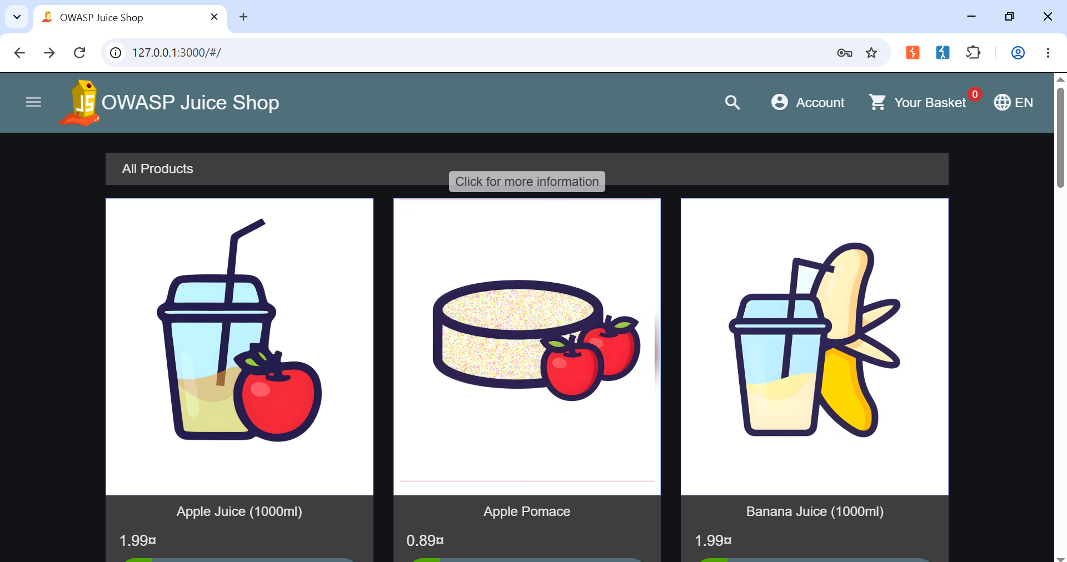

Understand it with a real-world example:

Imagine you open an online shopping website and log in to your account

password bug bounty:

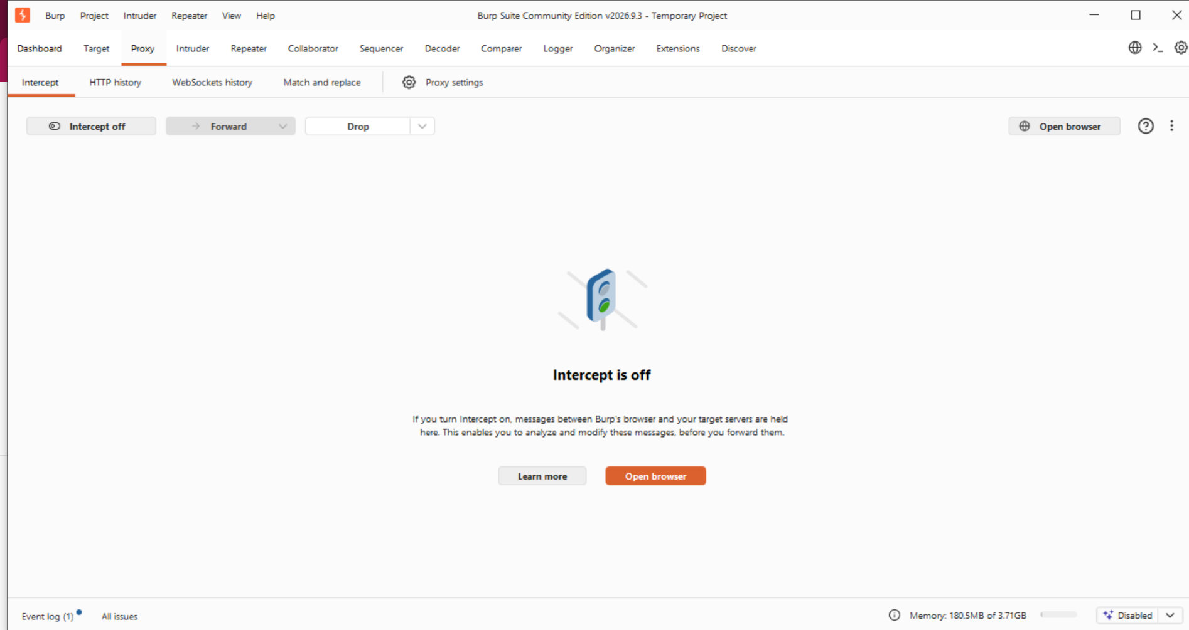

Then, click open Browser:

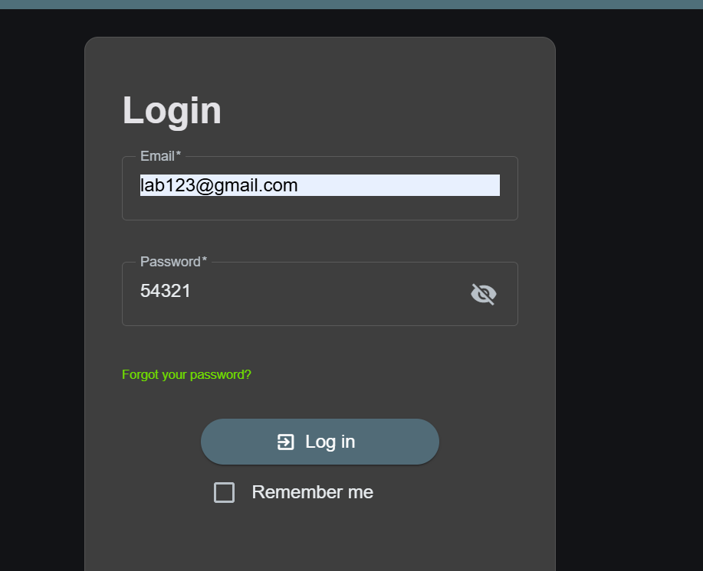

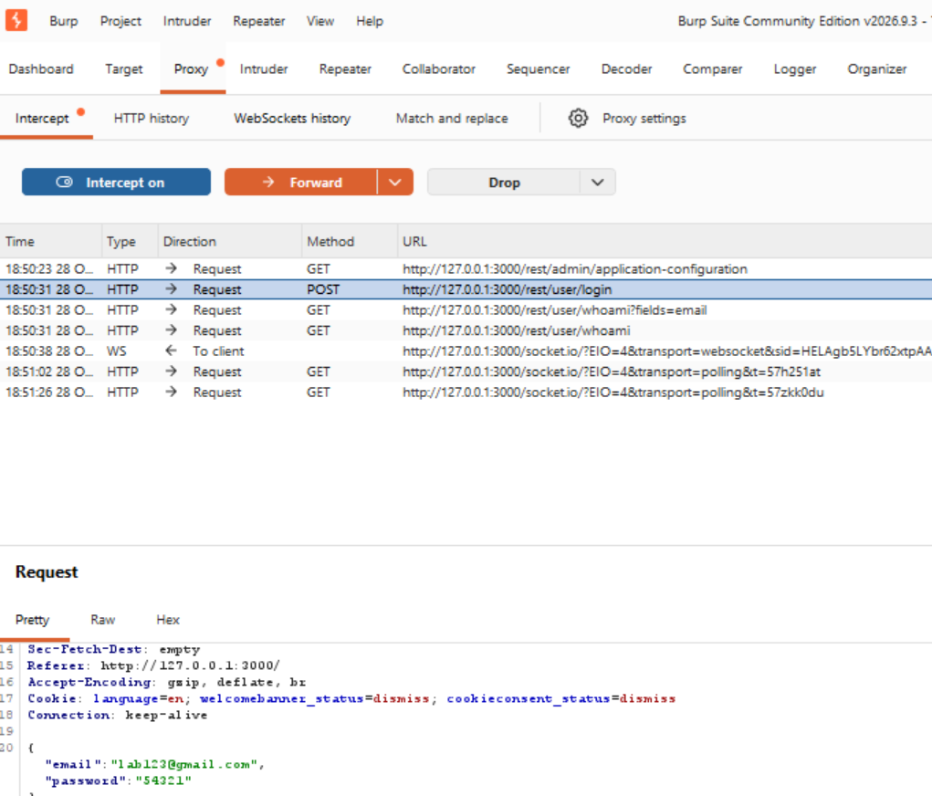

Ctrl +r -- > intruder(Highlight password) right click (add payload position)

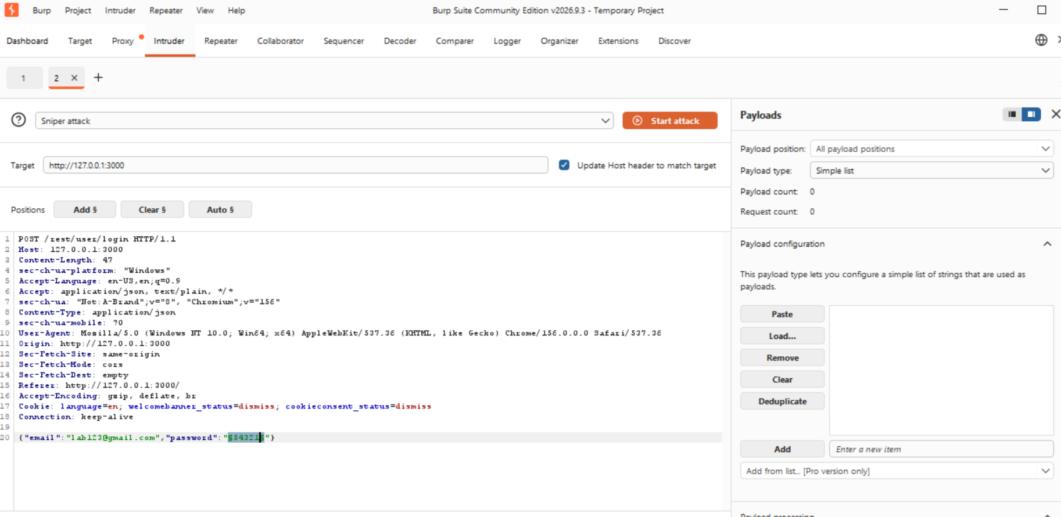

Then, add payload 5 digit password,

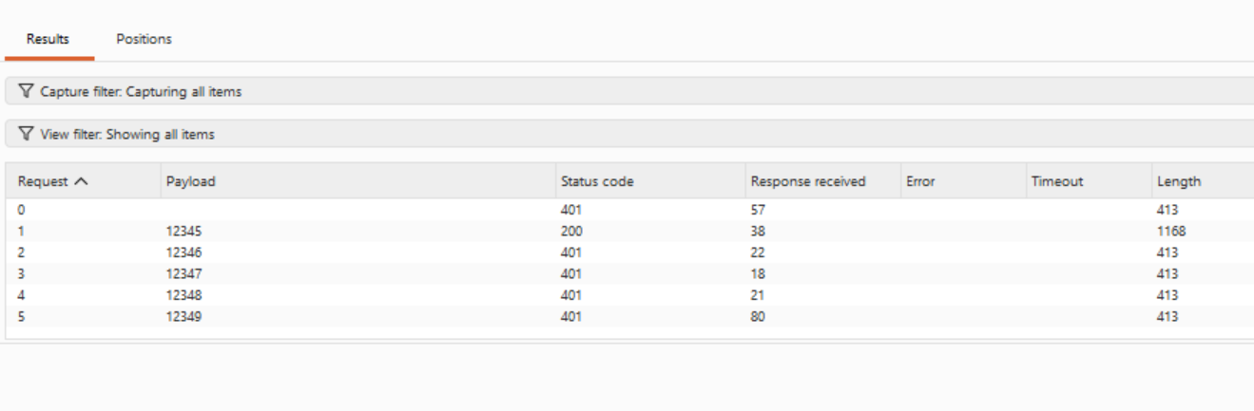

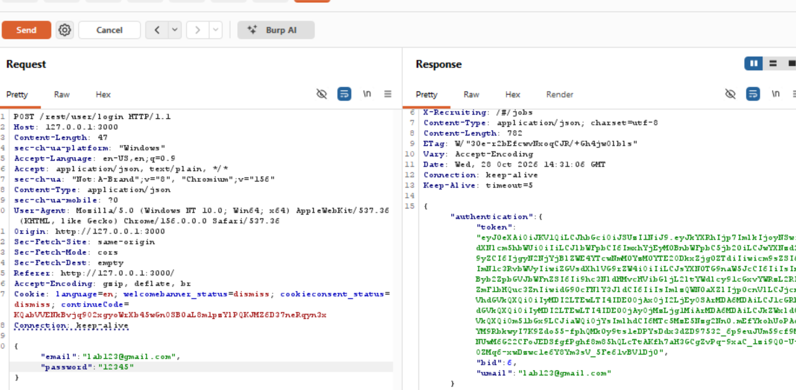

Review Changes:

